EPA 830-K-15-001
December 2015

November 2018
Portions of this are based on the template created by U.S. EPA that has been adapted to Iowa IDNR General Permit No.2
Template for Iowa Individual Construction Sites
Stormwater Pollution Prevention Plan

Insert Project Name ____________________________
Insert Legal Description (1/4,1/4, Section No. T,R) OR Plat Name________________________
Insert Project Site Location/Address ____________________________
Insert City, State, Zip Code_________________________
Insert Project/Site Telephone Number______________________

SWPPP Prepared For:

Insert Company or Organization Name_______________________
Insert Name_____________________________
Insert Address_________________________
Insert City, State, Zip Code____________________
Insert Telephone Number___________________
Insert Fax/Email____________________

SWPPP Prepared By:

Insert Company or Organization Name_________________________________
Insert Name________________________
Insert Address______________________
Insert City, State, Zip Code______________________
Insert Telephone Number_______________
Insert Fax/Email_______________

SWPPP Preparation Date:
Click here to enter a date.

SWPPP Revision Date (if applicable):
Click here to enter a date.
SWPPP Manager:__________________________________
Location of Project SWPPP during Construction:__________________________________
Receiving Water(s) and Ultimate Received Water(s)_____________________________________________________________________

SWPPP Contents

Part 1: Site and Activity Description 1
1. A. Transfer Agreements 1
1. B. Nature of Site Construction Activities 1
1. C. Runoff Coefficient
1. D. Receiving Waters
1. E. Estimated Dates that Construction Will Take Place
1. F. Contacts of Contractors and Subcontractors that will be Co-permittees 2
Part 2: Allowable Non-Stormwater Discharges 2
Part 3: Erosion and Sediment Controls 2
3. A. Soil Management: Topsoil Preservation and Stockpiling 3
3. B. Soil Management: Soil Compaction Minimization 3
3. C. Perimeter Controls 3
3. D. Sediment Track-Out 3
3. E. Dust Control 4
3. F. Storm Drain Inlet Control 4
3. G. Other Erosion and Sediment Controls (required based on site characteristics) 4
Part 4: Site Stabilization 5
4. A Type of Soil Stabilization 5
4. B. Soil Management and Soil Decompaction 5
4. C. Deadlines to Initiate and Complete Stabilization 5
Part 5: Stormwater Management (Post Construction) 6
5. A. Rain Gardens, Bioretention Cell, Bioswale, Permeable Pavers, Wetlands, Detention, Retention 6
Part 6: Pollution Prevention Practices 6
6. A. Potential Pollutants at This Project Site 6
6. B. Prohibited Discharges 6
6. C. Pollution Prevention Practices 6-7
Part 7: Control Installation and Removal Schedule 8
Part 8: Procedures for Maintenance, Inspections, and Corrective Actions 9
8. A. Inspections 9
8. B. Maintenance 9
8. C. Corrective Action 10
8. D. Training 10

Part 9: Erosion Control Site Maps, Plans and Drawings 11-12
Attachment and SWPPP Certification 13
APPENDIX CONTENTS 14-30

SWPPP Narrative

Part 1: Site and Activity Description

1. A. Transfer Agreements
  - Copies of Agreements are attached to this document in Appendix A ☐ YES ☐ NO ☐ N/A

1. B. Nature of site construction activities
  - This project will result in the construction of __________________________ dwellings/buildings in the same common plan of development or sale.
Lot Address | Total Lot Size (Acres) | Maximum Area of Construction Disturbance (Acres)
1.
2.
3.
4.
5.
6.

1. C. Runoff Coefficient
1. Runoff coefficient after construction is complete:_________________________________
Table 1 - TYPICAL "C" VALUES (ASCE 1960) (Information obtained from IDNR Summary Guidance for GP#2)
Description of area Runoff coefficient
Neighborhood Area | 0.50 - 0.70
Residential
Single-Family Areas | 0.30 - 0.50
Multi-Units, Detached | 0.40 - 0.60
Multi-Units, Attached | 0.60 - 0.75
Residential (Suburban) | 0.25 - 0.40
Apartment Dwelling Areas | 0.50 - 0.70
Drives and Walks | 0.75 - 0.85
Roofs | 0.75 - 0.95
Lawns - Course Textured Soil (Greater than 85 % Sand)
Slope: Flat, 2 % | 0.05 - 0.10
Average, 2 - 7 % | 010 - 0.15
Steep, 7 % | 0.15 - 0.20
Lawns - Fine Textured Soil (Greater than 40 % Clay)
Slope: Flat, 2 % | 0.13 - 0.17
Average, 2 - 7 % | 0.18 - 0.22
Steep, 7% | 0.25 - 0.35

D. Receiving Waters
- Description of receiving waters (Get from Developer SWPPP): INSERT TEXT HERE
- Describe location of closest of storm sewer intakes: INSERT TEXT HERE
- Description of impaired waters or waters subject to TMDLs (Get from Developer SWPPP):
INSERT TEXT HERE

E. Estimated dates that construction will take place
- Construction activities on this project will begin on or about: Click here to enter a date. (Note: once the actual date is known, correct the estimated date)
- All construction activities on this project will be completed on or about: Click here to enter a date. (Note: once the actual date is known, correct the estimated date)

1. F. Contacts of contractors and subcontractors that will be co-permittees
1. Identify person(s) responsible for compliance with GP#2 and local requirements.
Name | Responsibilities | I Have Read GP#2 And Understand the Applicable Requirements
1. |  | ☐ Yes Date: Click here to enter a date.
2. |  | ☐ Yes Date: Click here to enter a date.
3. |  | ☐ Yes Date: Click here to enter a date.

2. Copies of signed statements for all co-permittees are included in Appendix A.

Part 2: Allowable Non-Stormwater Discharges

List of Allowable Non-Stormwater Discharges Present at the Site
Type of Allowable Non-Stormwater Discharge | Likely to be Present at Your Site?
Discharge from emergency fire-fighting activities | ☐ YES ☐ NO
Fire hydrant flushings | ☐ YES ☐ NO
Irrigation drainage | ☐ YES ☐ NO
Water used to control dust | ☐ YES ☐ NO
Potable water including uncontaminated water line flushings | ☐ YES ☐ NO
Routine external building wash down that does not use detergents | ☐ YES ☐ NO
Pavement wash waters provided spills or leaks of toxic or hazardous materials have not occurred (unless all spill material has been removed) and where detergents are not used. | ☐ YES ☐ NO
Uncontaminated air conditioning or compressor condensate | ☐ YES ☐ NO
Uncontaminated, non-turbid discharges of ground water or spring water | ☐ YES ☐ NO
Foundation or footing drains where flows are not contaminated with process materials such as solvents or contaminated ground water | ☐ YES ☐ NO

Part 3: Erosion and Sediment Controls

The following controls to minimize erosion and sediment discharges in stormwater will be designed, installed, maintained, and removed in accordance with SUDAS Design Guidelines and Specifications in Appendix G and any specifications in Appendix B. Location on site for each of these practices is depicted in the attached site maps in Part 9: Site Maps.

3. A. Soil Management: Topsoil Preservation and Stockpiling. IDNR GP#2 2.A.(2).(c). Preserve topsoil unless infeasible

☐ Topsoil will be removed and stockpiled so that it can be re-applied for vegetative stabilization. (Show on site map)
Area stripped__________________acres ____________inches of topsoil
Where will the topsoil stockpile be located? (Show on site map)
☐ on lot ☐ in development ☐ other list____________________
What will be used for stockpile protection?
☐ vegetation and mulch ☐ tarp ☐ other list____________________
☐ It is infeasible to preserve topsoil at the site. Provide detailed explanation

3. B. Soil Management: Soil Compaction Minimization IDNR GP#2 2A.(2).(c). Minimize soil compaction unless infeasible.
The following practices will be used to minimize soil compaction:
☐ Protect Areas Reserved for Vegetation and Infiltration and Trees
☐ Other: (If you select "Other", describe type of control that you will use.)

3. C. Perimeter Controls IDNR GP#2 2.A.(2) Use structural practices to the degree attainable, to divert flows from exposed soils, store flows or otherwise limit runoff from exposed areas of the site.
The following practices will be used for perimeter controls:
☐ Silt Fence – SUDAS 7E-14, they will be staked in place and the end buried (Show on site map)
☐ Filter Sock or Wattle – SUDAS 7E-4 and 7E-6, there will be a shallow trench in which they will be installed and they will be staked in place. (Show on site map)
☐ Other: Provide description of controls and reference SUDAS section or attached design guideline in Appendix

3. D. Sediment Track-Out IDNR GP#2 2.C.(2) Off-site vehicle tracking of sediments shall be minimized.
The following type of sediment track-out control will be used at the site:
☐ Stabilized Rock Exit – SUDAS 7E-15, This will be replaced when full of sediment.
☐ Pads
How will sediment be cleaned off the street each day during active construction?
☐ Shovel ☐ Street sweeper ☐ Other list____________________
Who will be responsible for cleaning the sediment of the streets? Name and phone number__________________________________

3. E. Dust Control IDNR GP#2 Minimize generation of dust.
Dust control will include the following:
☐ Dust Control – SUDAS 7E-16n List method:

3. F. Storm Drain Inlet Protection IDNR GP#2 2A.(2). Protect storm drains.
This control is required on-site:
☐ Yes, because stormwater that leaves the property flows into a storm sewer inlet (without first flowing to a storm pond or other larger-scale control) that I have access to.
☐ No, because stormwater will not flow into a storm sewer inlet that drains from the site, or because it flows first into a sediment basin or trap.
If “Yes” is checked above, the following storm sewer inlet protection control will be used (select at least one if required).
Inlet Controls (choose one) - SUDAS 7E-20:
☐ Filter sock or Wattles ☐ Drop-in structure
☐ Sand or rock bags ☐ Other list____________________

3. G. Other Erosion and Sediment Controls (required based on site characteristics)
If you plan to use other erosion and sediment controls on your site that do not fall under any of the areas already covered above, describe them below:

Type of stormwater control: Describe any other stormwater controls used at the site
Date of installation: Select date - must be prior to start date of construction
Location on site: The attached site map shows where this control will be placed.
Design, installation, maintenance, and removal specifications: List SUDAS reference or provide copy of design guideline and specification
Date of installation: Select date - must be prior to start date of construction
Repeat “other controls” text as necessary.

 Part 4: Site Stabilization
The following controls will be used for temporary and permanent stabilization on the construction site. Location on site for each of these practices is depicted in the attached site maps.
IDNR GP#2 III.C.(3). Stabilization of disturbed areas must, at a minimum, be initiated immediately whenever any clearing, grading, excavating or other earth disturbing activities have permanently ceased on any portion of the site or temporarily ceased on any portion of the site and will not resume for a period exceeding 14 calendar days. In drought-stricken areas and areas that have recently received such high amounts of rain that seeding with field equipment is impossible and initiating vegetative stabilization immediately is infeasible, alternative stabilization measures must be employed as specified by the Department.

4. A. Type of soil stabilization (check all that apply and show areas on site map) IDNR GP#2 2A.(1)
☐ Vegetative (select specific type from options below):

☐ Temporary Seeding and Mulch – SUDAS 7E-22, 7E-17
☐ Permanent Seeding and Mulch – SUDAS 7E-24, 7E-17
☐ Sod – SUDAS 7E-25

☐ Non-vegetative cover (select specific type from options below):

☐ Erosion Control Blankets or Turf Reinforcement Mats – SUDAS 7E-5, 7E-18
☐ Mulching - SUDAS 7E-17

☐ Other type of vegetative or non-vegetative stabilization measure not listed above: Specify type and list SUDAS reference or provide design guideline and specification in Appendix.

4. B. Soil Management: Soil decompaction (show areas on site map) IDNR GP#2 2A.(2).c.

What methods will be used for soil decompaction after construction and to what depth? Iowa Stormwater Management Manual Soil Management and Quality Restoration
☐ Ripping _____inches ☐ Tilling____inches ☐ Other list____________________

4. C. Deadlines to initiate and complete stabilization IDNR GP#2 2A.(1.) & III.C.(3.)

- Deadline to initiate soil stabilization: Where work will not occur for 14 or more days in any area of bare soil on the site, stabilization will be initiated immediately on the day that work stops. Any of the following activities qualifies as initiating stabilization:
- Prepping the soil for vegetative or non-vegetative stabilization
- Applying mulch or other non-vegetative product to the area of bare soil
- Seeding or planting the exposed area
- Starting any of the activities in 1, 2, or 3 on a portion of the area to be stabilized, but not on the entire area
- Finalizing arrangements to have stabilization product fully installed

- Final Stabilization: For vegetative stabilization, complete all activities necessary to initially seed or plant the area to be stabilized. To achieve final stabilization, vegetation must provide 70 percent or more of the preexisting vegetative cover.

- Final Stabilization: For non-vegetative stabilization, complete the application of all non-vegetative measures in the area to be stabilized.

Part 5: Post Construction Stormwater Management

5. A. Post Construction Stormwater Management Practices. IDNR GP#2 2B.(1).
Some individual sites may include these features that are installed after the site is stabilized excluding soil quality restoration practices. Indicate on the site map where these are located.

☐ Rain Garden ☐ Bioretention cell ☐ Retention basin
☐ Permeable pavers ☐ Bioswale ☐ Constructed wetland
☐ Rainwater harvesting ☐ Detention basin Other List________________________
☐ None of these features will be used on this site

 Part 6: Pollution Prevention Practices

6. A. Potential Pollutants at this Project Site IDNR GP#2 2C.(1).
Identify the potential pollutant sources on the site (check all that apply)

☐ Sediment ☐ Wastewater from concrete, spec mixer washout, wet/dry saw cutting
☐ Paint, paint washout ☐ Wastewater from stucco washout/cleanout, grout washout
☐ Fertilizers ☐ Lime
☐ Plaster ☐ Fuels, oil and other chemicals
☐ Solid waste ☐ Portable toilet waste
☐ Treated lumber ☐ Roofing materials
☐ Pesticides, Herbicides ☐ Soaps, solvents, or detergents in vehicle and equipment washing

6. B. Prohibited Discharges
The following discharges are prohibited under the permit, and are considered a violation should any occur.
- Wastewater from washout of concrete, wet saw cutting, and from washout and cleanout of stucco, paint, form release oils, curing compounds and other construction materials.
- Fuels, oils, or other pollutants used in vehicle and equipment operation and maintenance.
- Soaps, solvents, or detergents used in vehicle and equipment washing
- Toxic or hazardous substances from a spill or other release.
In the event that one of these discharges occurs, corrective action will be taken consistent with Part 6c of this SWPPP. If this is a reportable spill, contact IDNR Spill Hotline 515-725-8694.

6. C. Pollution Prevention Practices
During the course of the construction project, the following practices will be implemented to minimize pollutant discharges from the site. These controls will be designed, installed, maintained, and removed in accordance with the specifications in Appendix C: Pollution Prevention Practice Specifications. Location on site for each of these practices is depicted in the attached site maps in Part 9: Site Maps. Where a practice does not apply to the site because the type of pollutant will not be present during any part of the project, this has been indicated as practice is “N/A” (Not Applicable).
Pollutant Sources | Pollution Prevention Practice  (See Appendix B for specifications) | Applicable to My Site?
Building products, materials, solid concrete waste and other wastes | Practice PP-1 - Materials Storage and Handling | ☑ Yes (required)
Pesticides, herbicides, insecticides, and fertilizers | Practice PP-1 - Materials Storage and Handling | ☐ Yes ☐ N/A
Diesel fuel, oil, hydraulic fluids, other petroleum products, and other chemicals | Practice PP-1 - Materials Storage and Handling | ☐ Yes ☐ N/A
Hazardous or toxic waste | Practice PP-1 - Materials Storage and Handling | ☐ Yes ☐ N/A
Construction and domestic waste | Practice PP-2 - Construction and Solid Waste Management | ☑ Yes (required)
Sanitary waste | Practice PP-3 - Sanitary Waste Management | ☐ Yes ☐ N/A
Washwater from paint, concrete, wet/dry saw cuttings or other applicators and containers | SUDAS Spec. 11, 060 Practice PP-4 - Concrete/Stucco Washout Controls | ☐ Yes ☐ N/A
Spill Kit will be provided onsite |  | ☐ Yes ☐ N/A

Describe any other pollution prevention practices to be implemented at the site: Insert text here.
Insert project specific spill plan and response procedures if applicable.

Part 7: Control (BMP) Installation and Removal Schedule

BMP INSTALLATION AND REMOVAL SCHEDULE
Appendix B provides specifications for typical small residential lot construction BMPs that are not included in SUDAS. Indicate which controls you selected for the site, and the date you will install and remove each selected control.

Practice Number |  Part 3 Erosion, Sediment, Velocity Controls | Included in this SWPPP? | Date of Installation | Date of Removal
 | Topsoil Preservation and Stockpiling | ☐ YES ☐ NO
 | Soil Compaction Minimization | ☐ YES ☐ NO
 | Perimeter Controls
 | - Silt Fence | ☐ YES ☐ NO
 | - Filter Sock or Wattle | ☐ YES ☐ NO
 | - Other List | ☐ YES ☐ NO
 | Sediment Trackout
 | - Stabilized Rock Entrance | ☐ YES ☐ NO
 | - Pads | ☐ YES ☐ NO
 | - Procedure for Daily Street Cleanup | ☐ YES ☐ NO
 | - Person Responsible for Street Cleanup | ☐ YES ☐ NO
 | Dust Control | ☐ YES ☐ NO
 | Storm Drain Inlet Protection | ☐ YES ☐ NO
 | Other Erosion, Sediment and Velocity Controls | ☐ YES ☐ NO
Practice Number |  Part 4 Soil Stabilization Controls | Included in my SWPPP? | Date of Installation | Date of Removal
 | Vegetative Controls
 | - Seeding and Mulch | ☐ YES ☐ NO
 | - Sod | ☐ YES ☐ NO
 | Non-Vegetative Controls
 | - Erosion Control Blankets or Turf Reinforcement Mats | ☐ YES ☐ NO
 | - Mulching | ☐ YES ☐ NO
 | Decompaction | ☐ YES ☐ NO
 | Deadline to Initiate the 0/14 Day Rule | ☐ YES ☐ NO
 | Part 5 Stormwater Management (Post Construction) Controls
 | List Practices Used
Practice Number |  Part 6 Pollution Prevention Practices | Included in my SWPPP? | Date of Installation | Date of Removal
 | Materials Storage and Handling | ☐ YES ☐ NO
 | Construction and Solid Waste Management | ☐ YES ☐ NO
 | Sanitary Waste Management | ☐ YES ☐ NO
 | Concrete/Stucco Washout Controls | ☐ YES ☐ NO
 | Wet & Dry Saw Cutting | ☐ YES ☐ NO

Part 8: Procedures for Inspections, Maintenance and Corrective Actions

8. A. Inspections IDNR GP#2 2.4. Qualified personnel shall conduct inspections at least once every 7 calendar days
Inspector name and qualifications: Insert inspector names and qualifications.
Name | Contact Information | Qualifications

Reduced inspection frequency for special circumstances (check any that apply to your site):
☐ For vegetated conditions when a specific area is stabilized within a larger development area under construction. Identify these areas on the site map and list dates area is stabilized:
Area #1 Click here to enter a date.
Area #2 Click here to enter a date.
Areas to be inspected: During each inspection, the following areas of the site will be inspected:
- Cleared, graded, or excavated areas of the site;
- Stormwater controls (e.g., perimeter controls, exit points) and pollution prevention practices (e.g., pollution prevention practices for vehicle fueling/maintenance and washing, construction product storage, handling, disposal) at the site;
- Equipment storage and maintenance areas;
- Areas where stormwater flows within the site;
- Stormwater discharge points; and
- Areas where stabilization has been implemented.
Inspection report: I will complete an inspection report within 24 hours of completing any site inspection consistent with the report template found at http://www2.epa.gov/national-pollutant-discharge-elimination-system-npdes/stormwater-discharges-construction-activities#resources.
Note: Be sure to attach completed inspection reports to the SWPPP.

8. B. Operation and Maintenance IDNR GP#2 VI.M.
The permittee shall at all times properly operate and maintain all facilities and systems of treatment and control (and related appurtenances) which are installed or used by the permittee to achieve compliance with the conditions of this permit and with the requirements of storm water pollution prevention plans.

If I find a problem with a stormwater or pollution control measure, I will:
- Initiate work to fix the problem immediately after discovering the problem, and complete such work by the close of the next work day, if the problem does not require significant repair or replacement, or if the problem can be corrected through routine maintenance; and
- Install a new or modified control and make it operational, or complete the repair, by no later than 7 calendar days from the time of discovery where feasible whenever the installation of a new erosion or sediment or pollution prevention control is needed. If infeasible to complete the installation/repair within 7 days, I will document why it is infeasible to complete the installation or repair and the modified schedule.

8. C. Corrective Action.
Required Corrective Action(s): I will immediately take all reasonable steps to minimize or prevent the discharge of pollutants until a permanent solution is installed and made operational, including cleaning up any contaminated surfaces so that the material will not discharge in subsequent storm events. I will conduct corrective action(s) for each of the following triggering conditions should they occur at my site.
- A required stormwater control was never installed, was installed incorrectly, or not in accordance with the requirements of the permit
- I became aware that discharges are not meeting applicable water quality standards
- A prohibited discharge is occurring or has occurred
- EPA requires corrective actions as a result of a permit violation found during an inspection
Corrective action report: For each corrective action taken, I will complete a corrective action report consistent with the corrective report template found at http://www2.epa.gov/national-pollutant-discharge-elimination-system-npdes/stormwater-discharges-construction-activities#resources.
Note: Be sure to attach completed corrective action reports to the SWPPP.
8. D. Training. IDNR GP#2 Qualified personnel shall inspect disturbed areas of the construction site.
Documentation for Completed Training:
Name (printed) | Title | Training/Certification | Click here to enter a date.
Name (printed) | Title | Training/Certification | Click here to enter a date.

Part 9: Erosion Control Site Maps/Plans and Drawings

MAP #1 – Pre-Construction (OR attach photo or air photo of site preconstruction)
Use this map to depict:
- Boundaries of your site
- Storm drain inlets
- Topography of the site, existing vegetative cover, and drainage patterns (Use arrows) onto, over, and from the site property
- Any slope greater than 5%
- Locations where construction activities and earth-disturbing activities will occur (e.g., limits of disturbance, building footprint)
- Flowpath of stormwater across site during pre-construction, show where stormwater leaves site

MAP #2 – Best Management Practices (OR insert lot map with the following information)
Use this map to depict:
- Locations of structures and/or other impervious surfaces (buildings, driveways, parking lots, sidewalks) to be constructed
- Location of designated areas (with signage in English and, as appropriate, Spanish) for sanitary and solid waste disposal, chemical/hazardous/construction materials storage,stucco/concrete/grout, paint washout, equipment storage and staging areas.
- Location of stabilized exit and stabilized parking areas
- Locations of all erosion, sediment, velocity controls (blankets, vegetative strips, mulch, filter socks, wattles, silt fence, berms, depressions)
- Location of stockpiles and protection, tree and vegetation protection
- Locations of street intake and beehive intake protection
- Drainage patterns onto, over, and from the site property after major grading activities
- Allowable non-stormwater discharges

Attachments
☐ I have included a copy of my Notice of Intent (NOI) and IDNR Letter of authorization email as well as a copy of IDNR GP#2 as attachments to this SWPPP.

SWPPP Certification

I certify under penalty of law that this document and all attachments were prepared under my direction or supervision in accordance with a system designed to assure that qualified personnel properly gathered and evaluated the information submitted. Based on my inquiry of the person or persons who manage the system, or those persons directly responsible for gathering the information, the information submitted is, to the best of my knowledge and belief, true, accurate, and complete. I am aware that there are significant penalties for submitting false information, including the possibility of fine and imprisonment for knowing violations.
Name (printed) | Title | Signature | Click here to enter a date.

SWPPP APPENDICES
Appendix A – Copy of Transfer Agreements and Certification Statements
Appendix B – Erosion, Sediment, Velocity Controls and Good Housekeeping Specifications Not Found in SUDAS
Appendix C – Copy of General Permit #2
Appendix D – Copy of NOI and IDNR Authorization Letter
Appendix E – Completed Inspection Reports
Appendix F – Completed Corrective Action Reports
Appendix G- Relevant SUDAS Specifications

APPENDIX A – COPIES OF TRANSFER AGREEMENTS and CONTRACTOR AND CO-PERMITTEE CERTIFICATION STATEMENTS

Transfer Agreement for Storm Water General Permit No. 2 – Same Authorization (IDNR-Created Document)

This form is to be used when the buyer of any lots in a development agrees and intends to be solely responsible for compliance under the seller’s storm water permit authorization and when the seller will continue to renew the existing storm water permit authorization for the development.

Seller’s storm water NPDES General Permit No. 2 authorization number in DNR’s storm water database:

______________ -- _______________

Name and location of permitted project as it appears in DNR’s storm water database:

_______________________________________________________________________________________

List lot numbers of all lots transferred, addresses including street names and numbers (if available) and any other information needed to identify the transferred property. Additional pages may be attached if necessary.

_______________________________________________________________________________________
_______________________________________________________________________________________
_______________________________________________________________________________________
_______________________________________________________________________________________

Printed or typed name of Seller:_____________________________________________________________
Printed or typed name of Buyer:_____________________________________________________________

Seller understands that as of the date of execution of this contract, Seller is solely responsible for renewing the existing storm water permit authorization under the DNR’s General Permit No. 2 until soil-disturbing activities on the property described above are completed and the ground has been stabilized with a permanent, perennial vegetative cover of sufficient density to preclude erosion. Seller may discontinue the authorization under General Permit No. 2 for the property described above only 30 days or more after giving Buyer written notice of such intent.

Buyer understands that as of the date of execution of this contract, Buyer is solely responsible for compliance with the DNR’s storm water NPDES General Permit No. 2 for discharging storm water under Seller’s storm water permit authorization for the property described above. Buyer therefore agrees and intends to comply with all requirements of the storm water NPDES General Permit No. 2 and all other applicable laws, rules, ordinances and permits regarding storm water discharges.

Signature of Seller: Date:
________________________________________ ____________________________

Signature of Buyer: Date:

________________________________________ ____________________________

Transfer Agreement for Storm Water General Permit No. 2 – Separate Authorization

This form is to be used when the buyer of any lots in a development agrees and intends to obtain a storm water permit authorization for the purchased lot(s), separate from the seller’s or another’s permit authorization.

Seller’s storm water NPDES General Permit No. 2 authorization number in DNR’s storm water database:

______________ -- _______________

Name and location of permitted project as it appears in DNR’s storm water database:

_______________________________________________________________________________________

List lot numbers of all lots transferred, addresses including street names and numbers (if available) and any other information needed to identify the transferred property. Additional pages may be attached if necessary.

_______________________________________________________________________________________
_______________________________________________________________________________________
_______________________________________________________________________________________
_______________________________________________________________________________________

Printed or typed name of Seller:_____________________________________________________________

Printed or typed name of Buyer:_____________________________________________________________
Buyer understands that as of the date of execution of this contract, the property described above is no longer covered by an authorization under the DNR’s storm water NPDES General Permit No. 2. Buyer also understands that discharging storm water from ground not stabilized with a perennial, vegetative cover of sufficient density to preclude erosion or discharging from any soil-disturbing activity for this property without storm water permit authorization coverage is a violation of state and federal law. Buyer therefore agrees to obtain an authorization under the DNR’s storm water NPDES General Permit No. 2 for the property described above if there is ground not stabilized with a perennial, vegetative cover of sufficient density to preclude erosion and prior to commencement of any soil-disturbing activity.

Signature of Seller: Date:

________________________________________ ____________________________

Signature of Buyer: Date:

________________________________________ ____________________________

Contractor and Subcontractor Certification Statement

NPDES Permit Authorization Number: _______________________________

Project Title: ________________________________ Address: ______________________________

Operator(s): ____________________________________________

The storm water pollution prevention plan must clearly identify for each measure in the plan, the contractor(s) and/or subcontractor(s) that will implement the measure. All contractors and subcontractors identified in the plan must sign a copy of the certification statement. Upon signing the certification, the contractor or sub-contractor is a co-permittee with the owner and other co-permittee contractors. All certifications must be included in the storm water pollution prevention plan.

All contractors and subcontractors identified in a storm water pollution prevention plan shall sign a copy of the following certification statement before conducting any professional service at the site identified in the storm water pollution prevention plan.

"I certify under penalty of law that I understand the terms and conditions of the general National Pollutant Discharge Elimination System (NPDES) permit that authorizes the storm water discharges associated with industrial activity from the construction site as part of this certification. Further, by my signature, I understand that I am becoming a co-permittee, along with the owner(s) and other contractors and subcontractors signing such certifications, to the Iowa Department of Natural Resources NPDES General Permit No. 2 for "Storm Water Discharge Associated with Industrial Activity for Construction Activities" at the identified site. As a co-permittee, I understand that I, and my company, are legally required under the Clean Water Act and the Code of Iowa, to ensure compliance with the terms and conditions of the storm water pollution prevention plan developed under this NPDES permit and the terms of this NPDES permit."

This certification is signed in reference to the above named project:

Contracting Firm Name: __________________________________

Address of Contracting Firm: ________________________________________________________

Phone Number of Contracting Firm: ________________________________

Name: _______________________________

Title: _________________________________

Signature: ____________________________ Date: ___________________

APPENDIX B – EROSION, SEDIMENT AND VELOCITY AND GOOD HOUSEKEEPING SPECIFICATIONS NOT FOUND IN SUDAS

Soil Stockpiling and Topsoil Preservation (ES-1)

Use: Protect soil stockpiles from contact with rainwater and/or runoff, and preserve native topsoil.
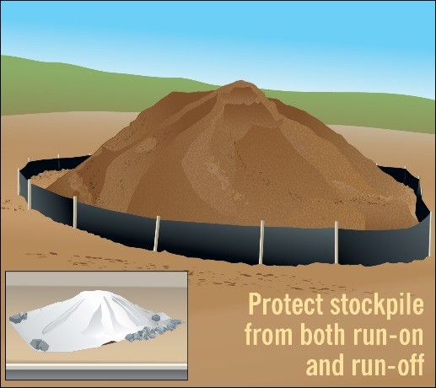
Application of silt fencing to control muddy runoff from soil stockpile. Leaving a site with quality soil encourages healthy root growth and reduces time and resources needed to care for turf and landscape plantings.
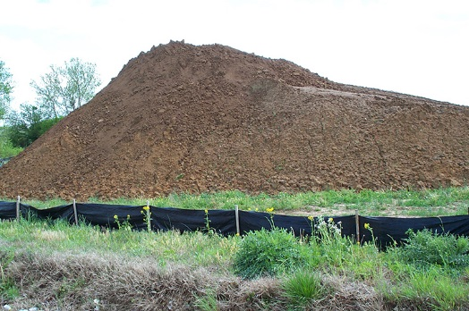
Silt fence around soil stockpile.
Photo credit: Barry Tonning, Tetra Tech

Location: Locate stockpiles away from storm inlets, conveyances, or other channelized flow. Locate topsoil stockpiles where they will not erode or block drainage structures, site entrances, or access to waste disposal areas.

Design criteria:
General soil and sediment stockpile criteria:
- Site operator(s) must protect stockpile from contact with stormwater (including water run-on) and/or prevent muddy runoff being discharged from the stockpile using a temporary perimeter sediment barrier. See (ES-2, Silt Fence Sediment Barrier and ES-3, Sediment Filter Log). If stockpile will be left uncovered for more than 14 days, apply temporary mulch or seed (see SS-1, Vegetative Stabilization – Seeding). For smaller stockpiles, plastic sheeting or tarps may be used. Unless infeasible, securely protect the stockpile from wind erosion (see ES-5, Dust Control).
Removing topsoil:
- Prior to stripping away topsoil (typically the first 4 to 6 inches of soil), ensure that all downslope erosion and sediment controls and upslope run-on diversions are in place. Avoid stripping topsoil from areas that will not be disturbed by excavation, grading, filling, or road building.
Topsoil storage:
- Where disturbance to native topsoil will occur at your site, unless infeasible, you should stockpile and reuse it in areas that will be stabilized with vegetation. To maximize the native topsoil’s continued function, when stockpiling native topsoil, you should mound the soil and cover to prevent soil erosion and weed growth. Uncovered stockpiles should be protected with a sediment barrier (e.g., silt fence, sediment filter log) around the downslope perimeter of the stockpile. As a guideline, soil should be mounded to a height of no higher than 4 feet for less than 1 year, and preferably for less than 6 months.
Reapplying Topsoil:
- Prior to placing topsoil in desired location, verify that subgrade has been graded and is structural stable. Perform pH tests whenever possible prior to soil placement in order to determine whether soil amendments or treatments are necessary to support vegetation growth.
- Loosen subgrade to a depth of 3 inches by disking or scarifying to ensure that topsoil bonds with underlying earth. Apply a minimum of 4 inches of topsoil. Do not spread topsoil when subgrade is wet or frozen.

Maintenance/Removal:
- See perimeter sediment barrier maintenance specifications (ES-2, Silt Fence Sediment Barrier and ES-3, Sediment Filter Log).
- Do not hose down or sweep leftover soil or sediment accumulated on pavement or other impervious surfaces into any storm drains or surface waters.

Dust Control (ES-5)

Use: Prevent fine-grained sediments from being blown away by wind to off-site areas or other on-site areas where they could subsequently be washed into surface waters.
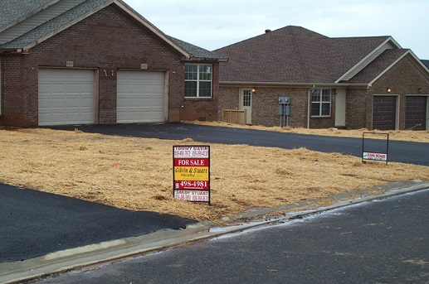
Straw mulch can be used to both prevent erosion and minimize dust from a site. Photo credit: Barry Tonning, Tetra Tech.

Location: Areas where exposed soil is vulnerable to wind erosion.

Design criteria:
Select control measures from the following list:
- Sprinkling/Irrigation. Sprinkle the ground surface with water until moist.
- Vegetative Cover. Use seed, sod, and/or other vegetative cover to stabilize areas that generate airborne dust. Follow requirements in SS-1, Vegetative Stabilization - Seeding or SS-2, Vegetative Stabilization - Sod, as applicable. Note: this is an effective method in areas not expected to handle vehicle traffic.
- Mulch. Follow specifications provided in SS-4, Non-Vegetative Stabilization - Mulching. Note: this is a quick and effective means of dust control for recently disturbed areas.
- Wind Breaks. Wind breaks are barriers (either natural or constructed) that reduce wind velocity through a site and, therefore, reduce the possibility of suspended particles. Wind breaks can be trees or shrubs left in place during site clearing or constructed barriers such as a wind fence, snow fence, tarp curtain, hay bale, crate wall, or sediment wall.

Maintenance:
- Inspect any installed controls regularly for deterioration to ensure that they are still achieving their intended purpose.
- Dust control measures must be modified or upgraded if site inspection shows evidence of wind erosion.

Tips:
- Phasing construction activities to minimize the total area disturbed at any one time can greatly reduce problematic dust on site.

Protect Areas Reserved for Vegetation and Infiltration (ES-6)

Use: Protect areas where vegetative stabilization or infiltration practices (e.g., rain gardens, bioswales, septic system drainfields) will be installed from excessive compaction.
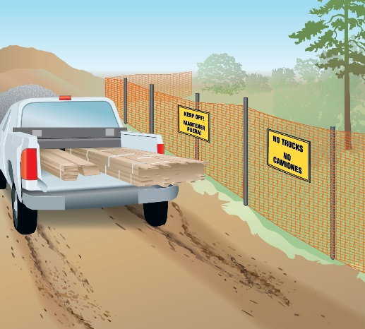
Protect vegetated areas using fencing or similar barriers. Include signage to notify workers not to enter the area.
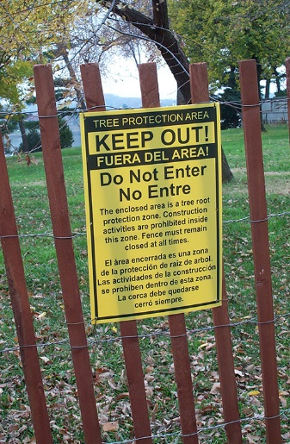
Use fencing and signage to ensure workers know not to disturb protected areas. Photo credit: Barry Tonning, Tetra Tech.
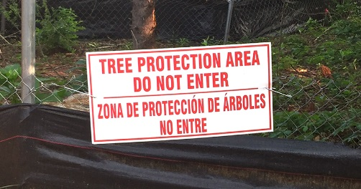
Signage for tree protection area. Photo credit: John Kosco, Tetra Tech.

Design criteria:
- Before the start of construction, identify protected and minimal disturbance areas with adequate signage in relevant languages (English, Spanish, etc.) and/or fencing.
- Train staff to avoid traffic and other impacts to protected areas.
- Indicate protected/minimal disturbance areas on site maps/drawings.
- Conduct soil restoration (i.e., conditioning) for areas that are not adequately protected or have been degraded by previous activities.

Maintenance:
- Replace fencing or signage as needed.

Tips:
- Provide adequate signage in relevant languages (English, Spanish, etc.) directing vehicle traffic on site.
- Clearly mark site entrance and exit, as well as drop-off areas for materials delivery and waste pickup.

 Materials Storage and Handling (PP-1)

Use: Prevent the discharge of leached pollutants and contaminated runoff from construction material stockpiles, chemicals, and hazardous waste.
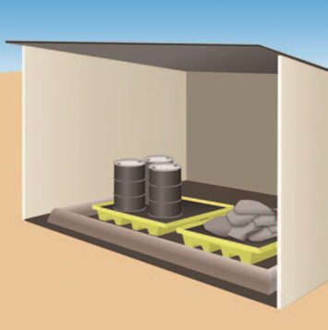
Shelter used to protect materials from rain. Secondary containment used to capture any spills.
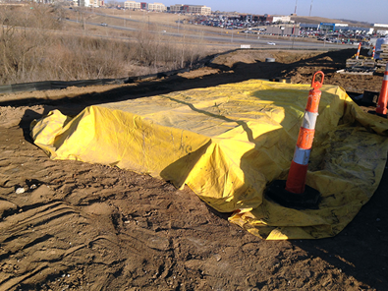
Cover materials using tarps or plastic sheeting to prevent precipitation from contacting construction site materials. Direct work crews to replace material stockpile covers at the end of the day and before rain. Photo credit: Barry Tonning, Tetra Tech

Design criteria:
- Designate separate waste collection areas for hazardous waste, construction waste, and domestic waste. Choose areas that do not receive a substantial amount of runoff and do not drain directly to a waterbody.
- Provide adequate signage marking each area in relevant languages (English, Spanish, etc.).
- Always unload and store materials away from storm drains and ditches.
- Use tarps, plastic sheeting, or other cover to protect stored construction materials. Use rope, bungee cords, heavy tape, etc. to secure tarps against wind.
Fuel, hazardous waste, chemicals and fertilizers:
- Store fuel, hazardous waste, and chemical products in sealed containers, which are constructed of suitable materials to prevent leakage and corrosion. Provide cover from rain, or provide a similarly effective means to prevent pollutant discharges. Provide secondary containment where necessary (e.g., spill berms, decks, and spill containment pallets).
- Label chemicals in accordance with applicable Resource Conservation and Recovery Act (RCRA) requirements and all other applicable federal, state, tribal, or local requirements. Comply with all application and disposal requirements on any applicable labels.
- Apply pesticides, herbicides, and fertilizers only as necessary, and at rates and in amounts consistent with manufacturer’s specifications, or document differences where appropriate. Apply fertilizers appropriately for the location, coinciding as closely as possible with maximum vegetation uptake and growth.
- Clean up spills immediately. For hazardous materials, follow clean up instructions on the package. Use dry, absorbent clean-up methods where possible, such as sawdust or kitty litter, to contain the spill. Do not clean surfaces or spills by hosing the area down. Eliminate the source of the spill to prevent further discharges.

Maintenance:
- Check downhill locations for storm drains and make sure they are protected.
- Direct staff to replace tarps and covers daily, especially before rain.

Tips:
- Coordinate with other site operators to ensure availability of clean up supplies.
- Know who to call – and their phone numbers – if major spills occur.

Construction and Solid Waste Management (PP-2)

Use: Reduce potential for stormwater runoff to mobilize construction site wastes and contaminate surface or ground water.
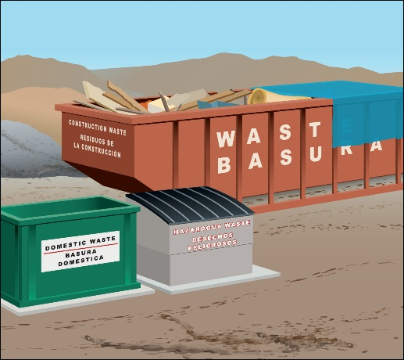
Designate waste collection areas on-site and provide adequate signage in English and Spanish.
Design criteria:
- Designate separate waste-collection areas on site for construction, domestic and hazardous waste. Locate waste collection areas away from streets, gutters, watercourses, and storm drains. Provide adequate signage in relevant languages (English, Spanish, etc.) to mark waste collection areas.
- If possible, locate dumpsters near construction site entrances to minimize traffic on disturbed soils.
- Provide waste containers of sufficient size and number to contain waste.
- Cover materials that might be displaced by rainfall or stormwater runoff with tarps, plastic sheeting, or other containment structures.
- Consider secondary containment around waste collection areas to further minimize the likelihood of contaminated discharges.
- Segregate and provide proper disposal options for hazardous material wastes (see PP-1, Materials Storage and Handling).
- On work days, clean up and dispose of waste in designated containers and clean up immediately if containers overflow.
- Clean up litter and debris from the construction site daily.

Maintenance:
- Inspect waste storage areas to identify containers or equipment that could malfunction and cause leaks or spills.
- Immediately repair or replace any containers that are found to be defective.

Tips:
- During storm events, waste should be stored in watertight dumpsters or securely covered.
- Salvage or recycle waste as appropriate and recycle materials whenever possible (e.g., paper, wood, concrete, oil).

Sanitary Waste Management (PP-3)

Use: Prevent the introduction of wastes from construction site toilet facilities to storm drains or receiving waters.
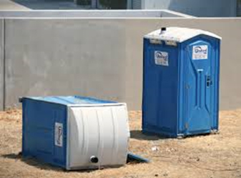
Position portable toilets so that they are secure and will not be tipped or knocked over. Photo credit: Kentucky Best Management Practices for Construction Activities, 2005

Design specifications:
- Provide accessible restroom facilities on-site.
- Portable toilets should not be located near drainage facilities or receiving waters, nor should they be located in areas that will collect water.
- Do not discharge or bury wastewater at the construction site.
- Position portable toilets so that they are secure and will not be tipped or knocked over.
- Provide secondary containment pans under portable toilets, where possible.
- Provide tie-downs or stake downs for portable toilets in areas of high winds.
- Educate employees, subcontractors, and suppliers on locations of facilities.

Maintenance:
- Inspect portable toilets for leaks, and repair or replace any leaks immediately.
- Maintain clean restroom facilities and empty waste regularly.
- Ensure that the sanitary/septic facilities are maintained in good working order and wastes are transported offsite by a licensed service.

Concrete/Stucco Washout & Wet Saw Cutting Controls (PP-4)

Use: Capture and hold concrete washout water and concrete waste. Use this BMP at sites in which concrete and stucco waste is present. Concrete waste is present at most construction sites. Wet saw cuttings can be vacuumed up or use an absorbent gel to contain and then dispose. Sweep up dry cuttings and dispose of properly.
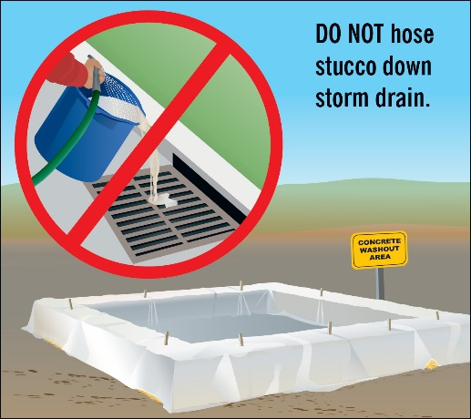
Large concrete washout fabricated from straw bales or filter socks, plastic sheeting, and wooden stakes. Note how sheeting extends well over sidewalls, and is tucked under bales.
Roll-off used for containment of wash-
out wastes.
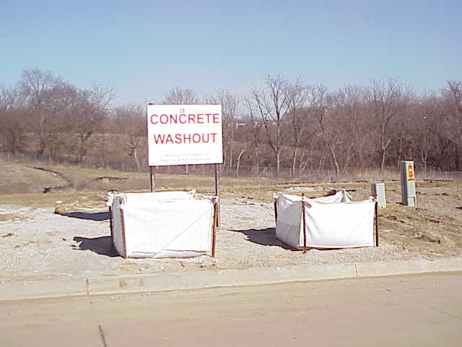

Location: Place washout area in a convenient location for concrete truck drivers, but away from storm drains, ditches, stormwater inlets, and surface waters.

Design criteria:
- Use pre-determined disposal sites for waste concrete.
- Provide adequate signage in relevant languages (English, Spanish, etc.) to mark washout area.
- Direct washout water into a leak-proof container, bag or pit designed so that no overflows will occur due to inadequate sizing or precipitation.
- Do not dump liquid wastes in storm sewers or surface waters, and locate washout and cleanout activities away from drainage features. If liquids are present and must be removed, dispose of liquid wastes consistent with the specifications in PP-1, Materials Storage and Handling.
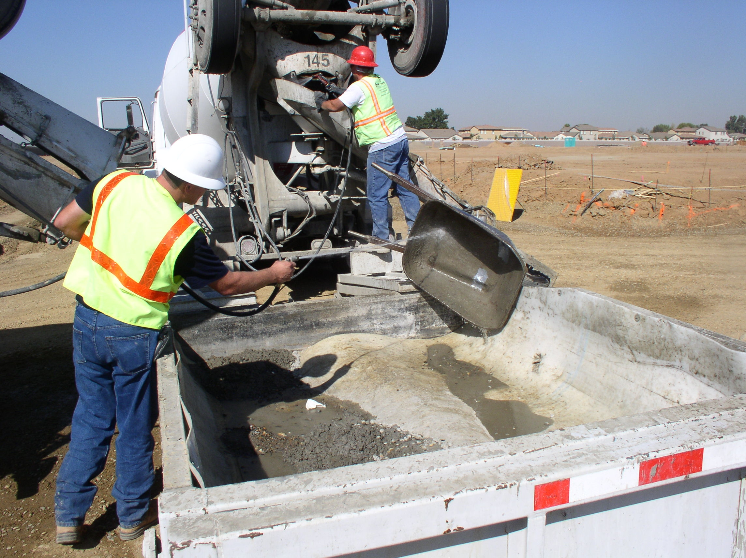
- Use an impermeable, durable plastic liner to prevent leakage of wash water.
- Construct basin sidewalls with filter sock, bales, or earthen berms. Fabricated washout tanks are available in some areas.
- Remove and dispose of hardened concrete waste consistent with how you dispose of other construction wastes as specified in PP-2, Construction and Solid Waste Management.

Maintenance:
- Inspect washout basins regularly for leakage and overflows.
- Immediately repair or replace any that are found to be defective.
- Cover washout basins that are full, to promote complete drying of contents prior to disposal.

Tips:
- Work with other builders to share washout basin responsibilities.
Waterproof bags used for containment of washout wastes.
- Drivers and equipment operators must be instructed on proper disposal and equipment washing practices (see above).
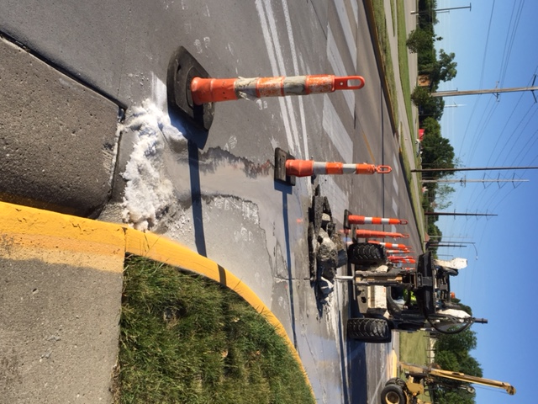
Removal:
When basin is full, allow contents to dry completely before removal.

Absorbent gel used to contain wet saw cuttings. Vacuums can be used as well.

APPENDIX C – COPY OF GENERAL PERMIT #2

Attach a copy of IDNR GP#2.

APPENDIX D – COPY OF NOI AND IDNR LETTER OF AUTHORIZATION

Attach a copy of your complete NOI form and IDNR’S authorization letter.

APPENDIX E – COMPLETED INSPECTION REPORTS

APPENDIX F – COMPLETED CORRECTIVE ACTION REPORTS https://www.epa.gov/npdes/stormwater-discharges-construction-activities#resources
Corrective Action Form

Project Name: | GP#2 Authorization No. |  |  |  |  |  |  | Today’s Date
Date Problem First Discovered |  |  |  |  |  | Time Problem First Discovered
Name and Contact Information of Individual Completing this Form
What site conditions triggered the requirement to conduct corrective action (check the box that applies):
A required stormwater control was never installed, was installed incorrectly, or not in accordance with the requirements
Stormwater controls that have been installed and maintained are not effective

A prohibited discharge has occurred or is occurring

Provide a description of the problem:

Deadline for completing corrective action (Enter date that is either: (1) no more than 7 calendar days after the date you discovered the problem, or (2) if it is infeasible to complete work within the first 7 days, enter the date that is as soon as practicable following the 7th day):

If your estimated date of completion falls after the 7-day deadline, explain (1) why you believe it is infeasible to complete work within 7 days, and (2) why the date you have established for making the new or modified stormwater control operational is the soonest practicable timeframe:
Section B – Corrective Action Progress
(Complete this section no later than 7 calendar days after discovering the condition that triggered corrective action)
Section B.1 – Why the Problem Occurred
Cause(s) of Problem  (Add an additional sheet if necessary) |  |  |  |  |  |  | How This Was Determined and the Date You Determined the Cause
1. |  |  |  |  |  |  | 1.
2. |  |  |  |  |  |  | 2.
Section B.2 – Stormwater Control Modifications to be Implemented to Correct the Problem
List of Stormwater Control Modification(s) Needed to Correct Problem  (Add an additional sheet if necessary) |  |  | Date of Completion |  | SWPPP Update Necessary? |  |  |  | Notes
1. |  |  |  |  | Yes No  If yes, provide date SWPPP modified:
2. |  |  |  |  | Yes No  If yes, provide date SWPPP modified:

APPENDIX G - Relevant SUDAS Specifications

FILTER SOCK
A. For slope and sediment control applications, use a continuous, tubular, knitted, mesh netting with 3/8 inch openings, constructed of 5 mil thickness, photodegradable HDPE.
B. For inlet protection, use a continuous, tubular, knitted, mesh netting with 3/8 inch openings, constructed of 500 denier polypropylene.
C. Use 1 inch by 2 inch (minimum) hardwood stakes or stakes of equivalent strength.
A. Installation:

1. Pneumatically fill mesh filter sock of size and length specified in the contract documents, or as directed by the Engineer. Alternative methods of filling the sock may be allowed upon approval of the Engineer.
2. Fill socks with filter material.
3. Place the filter sock along the contour as specified in the contract documents, or as directed by the Engineer.
4. Place additional filter material or soil from the site, on the upstream side of the sock, in the seam between the tube and the ground.
5. Construct a “J-hook” at each end of a continuous run of filter sock, by turning the end of the sock uphill, as necessary to prevent runoff from flowing around the ends when water behind the sock ponds up to a level even with the top of the sock.
6. Drive stakes into the ground at a maximum spacing of 10 feet, and as required to secure the sock and prevent movement
7. Repair or replace non-functioning filter socks that allow water to flow under the sock, are torn, or are otherwise damaged, due to inadequate installation.
8. Remove filter material from damaged socks that are located along streambanks, around intakes, in ditches, or in other locations where the material may be carried to surface waters.
B. Replacement:
1. When accumulated sediment reaches a level one-half the height of the sock, or when the sock becomes clogged with sediment and no longer allows runoff to flow through, remove the sock as described above, and replace according to the installation instructions above.
2. At the Engineer’s option, the existing filter sock and accumulated sediment may be left in place, and a new filter sock installed up-slope from the existing filter sock.

TEMPORARY ROLLED EROSION CONTROL PRODUCTS (RECP)
Use temporary rolled erosion control products that are classified and have material properties according to the Erosion Control Technology Council’s (ECTC) guidelines as follows:

A. Material Classification:

1. RECP Type 1 (Ultra Short-term): Functional longevity of 3 months or less and classified as follows:
a. RECP Type 1.A: Mulch control net, consisting of a photodegradable synthetic mesh or woven biodegradable natural fiber netting.
b. RECP Type 1.B: Netless rolled erosion control blankets, consisting of natural and/or polymer fibers, mechanically interlocked and/or chemically adhered together to form a RECP.
c. RECP Type 1.C: Single-net erosion control blankets and open weave textiles, consisting of processed degradable natural and/or polymer fibers, mechanically bound together by a single rapidly-degrading, synthetic or natural fiber netting, or an open weave textile of processed rapidly-degrading natural or polymer yarns or twines woven into a continuous matrix.
d. RECP Type 1.D: Double-net erosion control blankets, consisting of processed degradable natural and/or polymer fibers, mechanically bound together between two rapidly-degrading, synthetic or natural fiber nettings.
2. RECP Type 2 (Short-term): Functional longevity between 3 and 12 months and classified as follows:
a. RECP Type 2.A: Mulch control net, consisting of a photodegradable synthetic mesh or woven biodegradable natural fiber netting.
b. RECP Type 2.B: Netless rolled erosion control blankets, consisting of natural and/or polymer fibers, mechanically interlocked and/or chemically adhered together to form a RECP.
c. RECP Type 2.C: Single-net erosion control blankets and open weave textiles, consisting of an erosion control blanket composed of processed degradable natural or polymer fibers, mechanically bound together by a single degradable synthetic or natural fiber netting to form a continuous matrix, or an open weave textile composed of processed degradable natural or polymer yarns or twines woven into a continuous matrix.
d. RECP Type 2.D: Double-net erosion control blanket, consisting of processed degradable natural and/or polymer fibers, mechanically bound together between two degradable synthetic or natural fiber nettings.
3. RECP Type 3 (Extended Term): Functional longevity between 12 and 24 months and classified as follows:
a. RECP Type 3.A: Mulch control nets, consisting of a slow-degrading synthetic mesh or woven natural fiber netting.
b. RECP Type 3.B: Erosion control blankets and open weave textiles, consisting of processed slow-degrading natural or polymer fibers, mechanically bound together between two slow-degrading synthetic or natural fiber nettings to form a continuous matrix, or an open weave textile composed of processed slow-degrading natural or polymer yarns or twines woven into a continuous matrix.
Slope Application:

1. Grade and smooth surface. Remove all rocks, clods, vegetation, or other obstructions that will prevent direct contact between the RECP and the soil surface.
2. When specified, prepare seedbed and place seed and fertilizer according to Section 9010 prior to placing RECP.
3. Install anchor trench at top of slope. Seed and fertilize trench after backfill and compaction, if seeding is specified.
4. Unroll the RECP down or horizontally across the slope.
5. Place consecutive blankets down the slope end-over-end, shingle style.
6. Overlap ends of consecutive rolls a minimum of 3 inches, and install anchors at a maximum spacing of 18 inches along all overlaps.
7. Overlap edges of adjacent rolls a minimum of 2 inches.
8. Install anchors at edge seams between rows.

Channel/Ditch Application:

1. When specified, prepare seedbed and place seed and fertilizer according to Section 9010, prior to placing RECP.
2. Place end of first roll in the anchor slot at the center of the upstream channel and secure with anchors.
3. Position adjacent rolls in the anchor slot, overlapping adjacent rolls a minimum of 3 inches.
4. Place backfill material in anchor slot and compact. Unroll RECP over compacted slot and secure with anchors.
5. Unroll RECP downstream. Maintain a minimum 3 inch overlap between adjacent rolls. Secure edge lap with anchors.
6. Install intermittent staple check slots every 30 feet.
7. Construct end lap at end of roll and beginning of new roll. Overlap roll ends with upstream RECP on top.
8. Excavate longitudinal trench along both sides of the channel at the outside edges of installation. Place outer edges of RECP into longitudinal slot. Install anchors, place backfill material, and compact.
9. Terminate installation at downstream end with staple check.
10. Install anchors in a regular pattern over entire area covered according to manufacturer’s published recommendations (minimum three anchors per square yard).
WATTLES

A. Netting: Open weave, degradable netting. Nominal diameter of 9 inches, or as specified.
B. Fill Material: Straw, wood excelsior, coir, or other natural materials approved by the Engineer.
C. Stakes: 1 inch by 1 inch (minimum) wooden stakes, or stakes of equivalent strength.
Installation:

1. Construct a shallow trench, 2 to 4 inches deep, matching the width and contour of the wattle.
2. Install wattle along contour of slope.
3. Turn ends of wattle uphill to prevent water from flowing around ends.
4. Place and compact excavated soil against the wattle, on the uphill side.
5. Drive stakes through the center of the wattle, into the ground at a maximum spacing of 4 feet along the length of the wattle, and as needed to secure the wattle and prevent movement.
6. Abut ends of adjacent wattles tightly. Wrap joint with a 36 inch wide section of silt fence and secure with stakes.
Replacement:

1. When accumulated sediment reaches a level one-half the height of the wattle, or when the wattle becomes clogged with sediment and no longer allows runoff to flow through, remove the wattle as described above, and replace according to the installation instructions above.
2. At the Engineer’s option, the existing wattle and accumulated sediment may be left in place, and a new wattle installed up-slope from the existing wattle.
CHECK DAMS
A. Synthetic Permeable Check Dam (HDPE):
1. Ditch Berm:
a. Installed height of 9 to10 inches.
b. Manufactured check dam constructed from sheets of perforated, UV-stabilized High Density Polyethylene (HDPE).
c. Perforations of 30 to 40% open area.
2. RECP for Permeable Check Dam (when specified): RECP Type 4, 4 feet wide.
3. Anchors: As recommended by the manufacturer.
4. Installation
a. Install according to the manufacturer's recommendations.
b. When specified, provide an RECP under the check dam, installed according to the manufacturer’s recommendations.

B. Triangular Foam Check Dam: Triangular-shaped device with a height of 8 to 10 inches and a base of 16 to 20 inches.
1. Inner Support Material: Urethane foam.
2. Outer Cover: Woven geotextile material shaped to fit around the inner support material, extending 2 to 3 feet beyond the bottom edge of the triangular-shaped inner support.
3. Length: 7 feet.
4. Install according to manufacturers recommendations.
C. Rock Check Dam:
1. Aggregate: Erosion stone complying with Iowa DOT Article 4130.04.
2. Engineering Fabric: Comply with Section 9040, 2.18.
3. Construct according to Figure 9040.107.

A. Class A Revetment: Comply with Iowa DOT Section 4130.
B. Class B Revetment: Comply with Iowa DOT Section 4130.
C. Class D and E Revetment: Comply with Iowa DOT Section 4130.
D. Erosion Stone: Comply with Iowa DOT Section 4130.

Removal of Check Dams:
When specified in the contract documents, or as directed by the Engineer, remove check dams upon completion of the project, and after final stabilization is achieved; or as indicated in the SWPPP, if applicable.
1. Remove the check dam and dispose of materials, or salvage to the contractor.
2. Remove the accumulated sediment or spread to match finished grade; ensure proper drainage.
3. Stabilize the area disturbed by removal operations.

SILT FENCE
A. Fabric: Comply with Iowa DOT Article 4196.01.
B. Posts: 4 foot minimum steel (T-section) weighing at least 1.25 pounds per foot, exclusive of anchor plate. Painted posts are not required.
C. Fastener: Wire or plastic ties with a minimum tensile strength of 50 pounds.

Installation:

1. Install material along the contour of the ground, as specified in the contract documents, or as directed by the Engineer.
2. Install silt fence with a mechanical soil slicing machine that creates a slit in the ground while simultaneously installing the fabric. The trenching method may be used when situations will not allow soil slicing, as determined by the Engineer.
3. Construct a “J-hook” at each end of a continuous run of silt fence, by turning the end of the silt fence uphill, as necessary to prevent runoff from flowing around ends when water behind the fence ponds to a level even with the top of the fence.
4. Insert 12 inches of fabric to a minimum depth of 6 inches (fabric may be folded below the ground line).
5. Compact installation by driving along each side of the silt fence, or by other means, as necessary to adequately secure the fabric in the ground, to prevent pullout and water flow under the fence.
6. Drive steel posts into the ground alongside the silt fence, to a minimum depth of 20 inches, unless otherwise specified by the Engineer. Space posts as shown on Figure 9040.119 or as required to adequately support silt fence.

Maintenance:
Repair or replace non-functioning silt fence that allows water to flow under the fence, is torn, or is otherwise damaged, due to inadequate installation, at no additional cost to the Contracting Authority.
Replacement:
1. When accumulated sediment reaches a level one-half the height of the fence, remove the silt fence as described above, and replace according to the installation instructions above.
2. At the Engineer’s option, the existing silt fence and accumulated sediment may be left in place, and a new silt fence installed up-slope from the existing silt fence.
3. When allowed by the Engineer, the existing silt fence may be left in place and the accumulated sediment removed to the original ground line and within 6 inches of the silt fence. Carefully inspect the existing silt fence for structural integrity and signs of undermining. Make any necessary repairs.

STABILIZED CONSTRUCTION ENTRANCE
A. Entrance Stone: Comply with Iowa DOT Section 4122, Gradation 13, Macadam crushed stone.
B. Subgrade Stabilization Material: Use woven, UV-stabilized geotextile with a minimum tensile strength of 135 lb/ft.
A. Install a stabilized construction entrance at all locations where construction traffic leaving the site presents the potential for sediment track-out.
B. Remove vegetation and excavate soft soils from entrance area. Thoroughly compact subgrade prior to placing stone.
C. Install culvert under entrance if necessary to maintain drainage.
D. Grade entrance to prevent runoff from flowing onto street. Direct all runoff from entrance to a sediment retention device.
E. When specified, install subgrade stabilization fabric prior to placing crushed stone.
F. Install layer of crushed stone to the thickness (6 inches minimum) and dimensions specified in the contract documents.
G. Remove the accumulated sediment and install new stone, as required to prevent track-out.

DUST CONTROL
A. Water: Use potable water or water from a source approved by the engineer.
B. Calcium Chloride: Comply with Iowa DOT Article 4194.01.
C. Lignosulfonate (Tree Sap): Use a commercially-available product with known lignin content.
D. Soapstock (Soybean Oil):
1. Use a commercially-available, undiluted, soybean oil soapstock emulsion.
2. Comply with manufacturer’s recommendations for storage, transportation, temperature, and application equipment requirements.
A. Water: Apply frequent light watering to ground surface, as required to control dust.
B. Calcium Chloride: Apply according to Iowa DOT Section 2314.
C. Lignosulfonate (Tree Sap):
1. Loosen the top 1 to 2 inches of the roadway surface.
2. Apply solution with a 50% residual concentration, at a rate of 0.50 gal/yd2, to deliver a 25% residual. For diluted solutions, increase the application rate, as required, to deliver an equivalent 25% residual.
3. Allow product to penetrate through the loosened material.
4. Tight-blade road surface.
D. Soapstock (Soybean Oil):
1. Loosen the top 1 to 2 inches of the roadway surface.
2. Apply undiluted soapstock at a rate of 0.70 gal/yd2.
3. Allow product to penetrate through the loosened material.
4. Tight-blade road surface.

EROSION CONTROL MULCH
A. Conventional Mulch:
1. Use dry cereal straw (oats, wheat, barley, or rye) or native grass straw.
2. Use material that is free of noxious weeds, seed-bearing stalks, or roots, and will be inspected and approved by the Engineer prior to use.
3. Other materials, subject to the approval of the Engineer, may be used.
B. Hydromulch:
1. Wood Cellulose Mulch: Comply with Section 9010, 2.07.
2. Bonded Fiber Matrix (BFM): Comply with Section 9010, 2.07.
3. Mechanically Bonded Fiber Matrix (MBFM): See Section 9010, 2.07.
A. Conventional Mulching Installation:
1. Use conventional mulching when the surface cannot be stabilized by seeding, due to season or ground conditions.
2. Uniformly distribute mulch over the required areas, at a rate of 2 tons/acre for dry cereal straw, or 2.5 tons/acre for prairie hay.
3. Work the mulch into the soil with a mulch tucker, designed to anchor the mulch into the soil, by means of dull blades or disks.
B. Hydromulching Installation:
1. Place mulch and tackifier (if applicable) in equipment specifically manufactured for hydraulic mulching.
2. Mix materials with fresh, potable water using a combination of re-circulation through the equipment’s pump and mechanical agitation to form a homogeneous slurry.
3. If necessary, dampen any dry, dusty soil as required to prevent balling of the material during application.
4. Apply hydromulch in multiple layers from opposing directions, where possible.
5. Apply the slurry evenly over all specified areas, at the minimum component material rates specified:

Application Rates
Wood Cellulose Mulch:
1) Mulch: 2,600 lb/acre dry weight.
2) Tackifier: 50 lb/acre.
Bonded Fiber Matrix: 3,600 lb/acre dry weight.
c. Mechanically Bonded Fiber Matrix: 3,600 lb/acre dry weight.
6. Retain and count empty bags of mulch to ensure final application rate.

TURF REINFORCEMENT MATS (TRM)
A. Material Classification:
1. TRM Type 1: Use a TRM that is constructed of a web of mechanically or melt-bonded polymer netting, monofilaments, or fibers that are entangled to form a strong and dimensionally stable mat. Bonding methods include polymer welding, thermal or polymer fusion, or the placement of synthetic fibers between two high-strength, biaxially-oriented nets, mechanically bound by parallel stitching with polyolefin thread. Products may contain a degradable component.
2. TRM Type 2 and 3: Use a TRM that is constructed of a web of mechanically or melt-bonded polymer netting, monofilaments, or fibers that are entangled or woven to form a strong and dimensionally stable mat. Non-woven bonding methods include polymer welding, thermal or polymer fusion, or the placement of fibers between two high-strength, biaxially oriented nets, mechanically bound by parallel stitching with polyolefin thread. Use only components that are 100% synthetic and resistant to biological, chemical, and ultraviolet degradation.
3. TRM Type 4: Use a high performance/survivability TRM that is composed of monofilament yarns woven into a resilient uniform configuration. Use a mat that has a matrix that exhibits very high interlock and reinforcement capacities with both soil and root systems and demonstrate a high tensile modulus. TRMs manufactured from discontinuous or loosely held together by stitched or glued, netting, or composites are not allowed in this category. Use only components that are 100% synthetic and resistant to biological, chemical, and ultraviolet degradation. Use this category when field conditions exist with high loading and/or high survivability requirements.
Install according to the manufacturer’s published installation literature for the product specified and application (slope or channel).
INLET PROTECTION
A. Drop-in Intake Protection:
1. Use a manufactured device that is inserted into the intake and is capable of trapping or filtering sediment from runoff prior to entering the storm sewer.
2. All components must be contained entirely below the surface of the intake grate.
3. Incorporate means of emergency outflow to prevent flooding if plugged with sediment.
B. Surface-applied Intake Protection:
1. Use devices or filter socks, placed around or over the intake, that are capable of trapping or filtering sediment from runoff prior to entering the storm sewer.
2. Do not allow the device to completely block or plug the intake, preventing inflow.
A. Install inlet protection devices according to the manufacturer’s recommendations.
B. Remove the accumulated sediment, as required to maintain the inlet protection device in working order. Remove any accumulated sediment from streets open to traffic if it encroaches into the traveled roadway.
FLOW TRANSITION MATS
Comply with the following and Iowa DOT Materials I.M. 469.10.
A. Mat:

- Constructed of 85% minimum UV resistant material with a maximum ground cover of 80%.
- Meet the requirements of the following table:
Property | Test Method | Value
Mass/Unit Area (max.) | ASTM D 6566 | 3 lbs/SF
Minimum Thickness | ASTM D 6525 | 0.4 inch
Maximum Thickness | ASTM D 6525 | 1.1 inch
Tensile Strength | ASTM D 6818 | 550 lbs/ft
Minimum Percent Open Area | ASTM D 6567 | 20%
UV Stability | ASTM D 4355 | 85%

B. Anchoring Devices:
1. Furnish bullet tip style anchors made of a metal alloy attached to a wire rope.
2. Anchors capable of withstanding a minimum 300 pounds (136 kg) of pull out resistance in cohesive soils.
3. Wire rope a minimum of 30 inches (762 mm) in length with a minimum breaking strength of at least 300 pounds (136 kg).
4. The top washer a minimum of 3 inches (76 mm) in diameter and constructed of a UV resistant plastic.
5. Each anchor equipped to allow the retightening of the anchor when deemed necessary by the Engineer.
Install according to the manufacturer’s published recommendations.
TEMPORARY EROSION CONTROL SEEDING
Comply with Section 9010.

